Madeiracloud provide real-time monitoring service. The performance data on ide will be updated every 5 seconds. Metrics include CPU usage, memory usage, network traffic, disk IO and file system usage.

- Enable monitoring
You need to launch a new app at first. Then you can see the button of install agent when you click any metric on the top or right click the instance icon in the overall view. 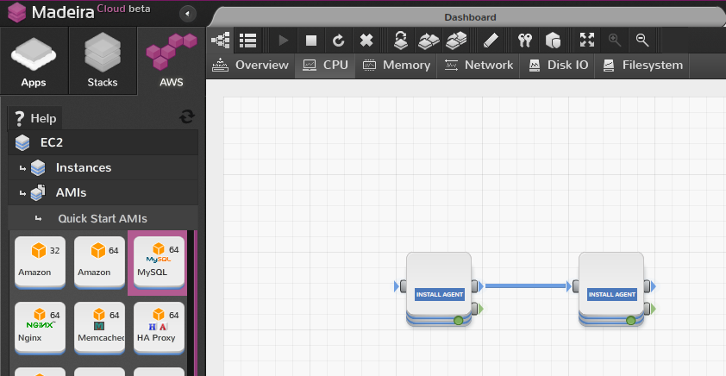
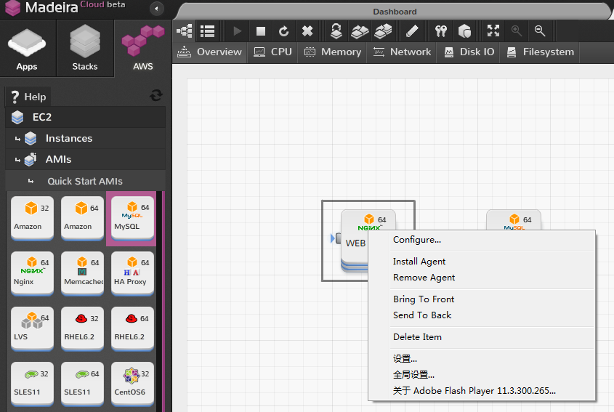
A tab which contains the linux command or windows URL will be showed. You can install the linux agent by running only one command or windows agent by only copy your unique user id and app id.
Tab to show how to enable linux instance monitoring.
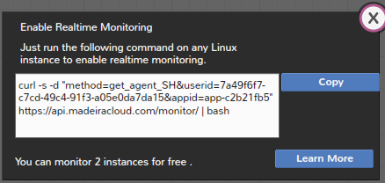
Tab to show how to enable windows instance monitoring.
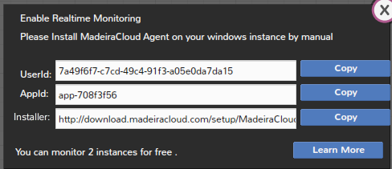
After running the command on linux or install on windows, the state of icon will be changed to monitoring in a few seconds.
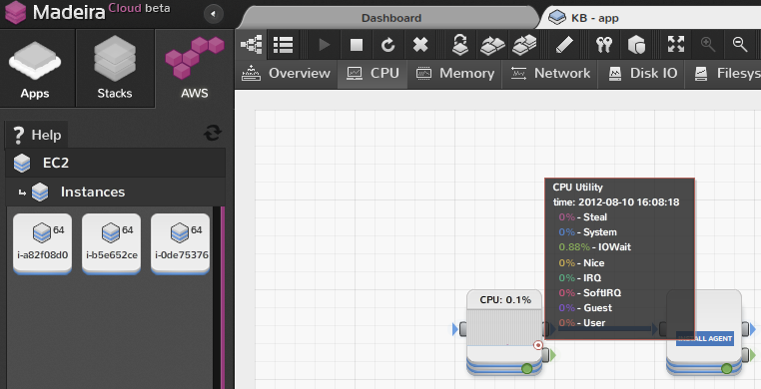
- How to use monitoring

You can check other metric just one click on the top.
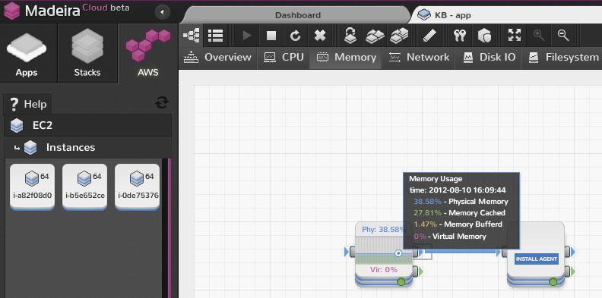

If you want to check all the metric on one page, just easily click the list button. On the list page, you can check all the performance metric within 10 minutes. When you move the mouse on any point of any metric diagram we will display all the data at that time.

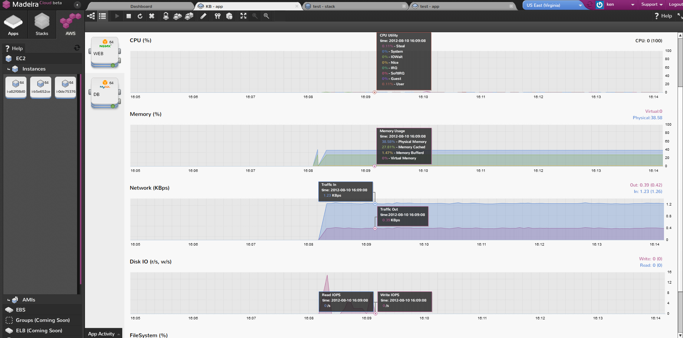

If you want to check the history data, you can click the history button and select when you want to start and end.
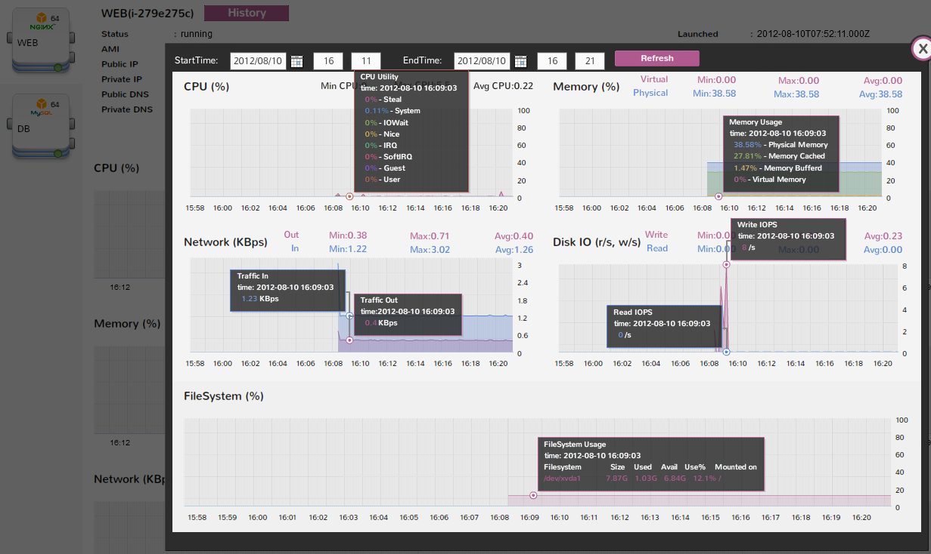

Another feature of our monitoring service is that support monitoring alert. Currently, we support app rule or instance rule. App rule is for the whole app meanwhile instance app is for specific instance. The priority of instance rule is higher than app rule.
You can define the instance rule by double click the instance icon on overall view or list page and define the app rule on the right panel of topology view.
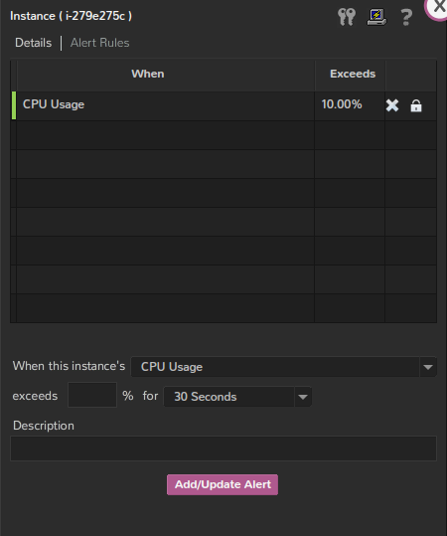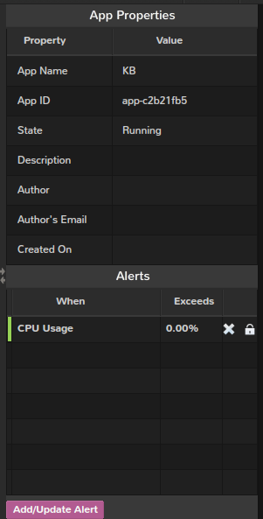

The alert will be triggered when the instance meet the rule. Then, the alert will be displayed it on ide and send a notification email. The notification will be triggered again if you only acknowledge the alert without solve the problem.
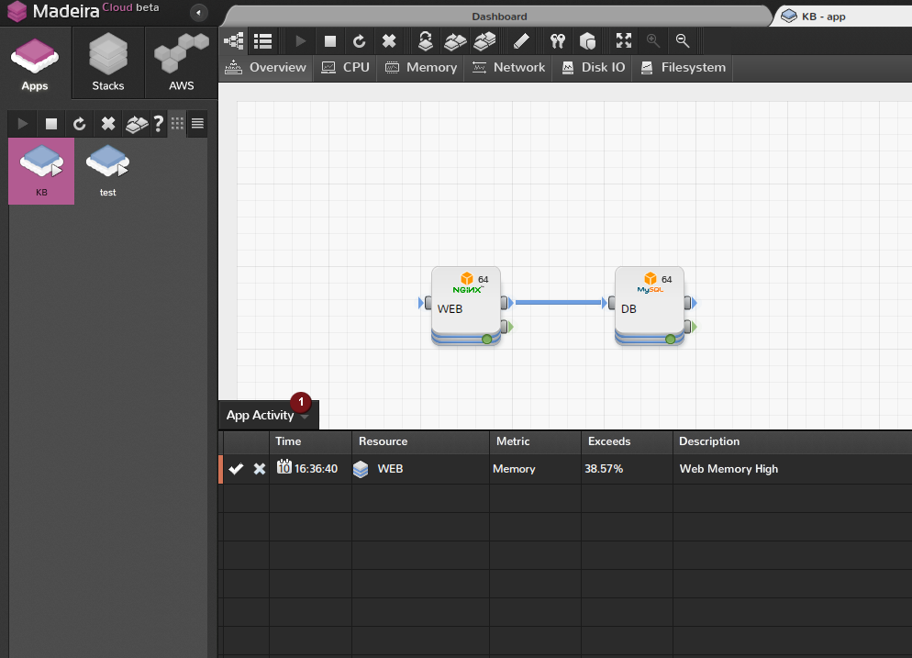

- Disable monitoring
Since the number of free monitoring instance is limit. Hence you might need to disable some monitoring instances when you want to monitoring other new instances. But be careful because after you click remove, all the performance data will be removed.
